Triathlon Race Manual
2020-21 Season

Updated 22 November 2020

INDEX

Index | 2
Participant Information | 3
Race Location | 3
Parking | 4
Road Closures | 4
Event Schedule | 4
Course Information & Maps | 5
Registration | 5
Race Briefing | 5
Timing | 5
Medical Fitness/Signed Waiver | 5
Medical | 6
Aid Station | 6
Toilets | 6
Race Rules | 6
Cut Off Times | 7
Environmental Respect | 7
Rules for Family, Friends & Supporters | 7
Transition Procedures | 7
Race Course Details & Layout | 8
Swim Leg | 8
Transition 1 – Swim to Bike | 9
Bike Leg | 10
Transition 2 – Bike to Run | 12
Run Leg | 13
Finish | 14
Results & Prize Giving | 14
Collection of Personal Belongings | 14
Lost Property | 14
Contingency Plan | 15

PARTICIPANT INFORMATION

Balmoral Triathlon Club (BTC) races are open to all participants aged 18 years or over who are:

- BTC members,
- Triathlon NSW members (where not a member of BTC), or
- Non-BTC/Triathlon NSW members (where neither a member of BTC or Triathlon NSW).

Participants aged 15 to 17 years who are members of BTC may enter BTC races subject to a bike skill assessment by a Level 2 coach prior to entering the race. BTC reserves the right to cancel race entries where this requirement has not been met.

RACE LOCATION

BTC races are held at Middle Head in Mosman, NSW, 2088. Registration and transition are located on the grassy area opposite HMAS Penguin, at the bottom of the hill on Middle Head Road.

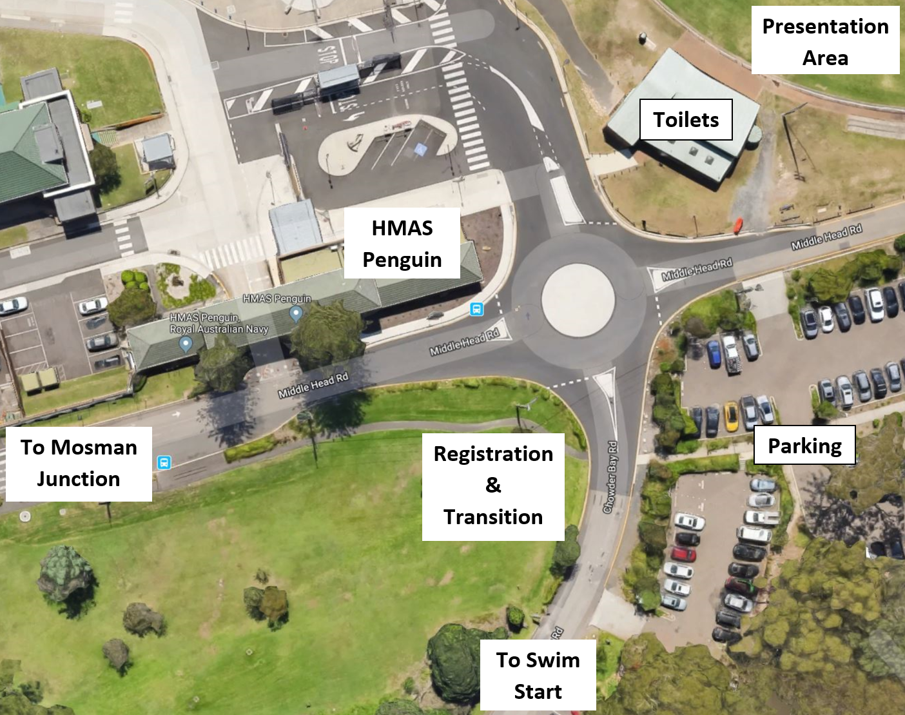

PARKING

Parking is available close to transition in several pay-and-display car parks located along Middle Head Road after passing HMAS Penguin and continuing straight over the mini-roundabout at the bottom of the hill. Please do not park on or next to the bike course as this will delay the start of the race.

ROAD CLOSURES

Chowder Bay Road will be closed to all vehicles between 6:30am and 7.45am. Police will be stationed at the start of the bike course to prevent vehicles entering from Middle Head Road. BTC cannot guarantee Chowder Bay Road will be free from traffic – competitors and supporters should remain vigilant at all times when moving along or crossing this road.

EVENT SCHEDULE

OPENS | EVENT | LOCATION
5.30am | Registration & Transition Open | Transition Area
6.00am | Race Official (Volunteers) Briefing. | Transition Area
6.15am | Registration & Transition Closes | Transition Area
6.20am | Please make your way down to Obelisk Beach for swim start | Swim Start, Obelisk Beach
6.30am | Race Start | Obelisk Beach
7.00am | Swim Course Closes | Obelisk Beach
7.30am | Last Lap Cut-Off For Bike Course  No competitor will be allowed to start another lap after this time | Chowder Bay Road
7.45am | Bike Course Closed & Road Opened To Traffic  All competitors must be off the bike course at this time | Chowder Bay Road
8.30am | Race Finish | Middle Head Oval

COURSE INFORMATION & MAPS

Course maps and descriptions are set out in this race manual. Competitors should familiarize themselves with the course maps and descriptions prior to race day.

REGISTRATION

Registration will take place on race morning on the grassy area opposite HMAS Penguin from 5.30am to 6.15am. Registration after this time is NOT permitted and you will not be allowed to race.

At registration, competitors will be cross checked against the on-line entrant list and will be issued with a race bib and a pink swim cap. (Please bring a race belt or safety pins to attach the race bib to the front of your body. The race bib must be worn during the cycle and run legs).

RACE BRIEFING

Race briefing will be online. Please look and listen to the race brief prior to the day. All competitors must have read/listened to the race brief prior to competing.

TIMING

BTC races use a manual timing system (no electronic chip).

Your responsibilities as a competitor are:

- You will be issued with a race bib when you register (worn during run and bike leg. Please ensure race number is on the front of the body during the run leg).
- Ensure you know your race number, which is written on the bib.
- As you cross the finish line, call out your race number so that race officials can record your finish time as accurately as possible
- If you need to withdraw from the race at any time, please let race officials know. It is essential for us to ensure all competitors are accounted for.

MEDICAL FITNESS/SIGNED WAIVER

You are reminded of your acceptance of entry conditions, waiver release and indemnification. Please note this is a legal part of the form and affects your rights. You have attested your physical condition to participate in this event. If you have developed a medical condition since you registered to enter, this should be brought to attention and where deemed appropriate by the Race Director, a medical certificate produced.

MEDICAL

If you have any specific medical conditions or are taking any specific medication, please notify race officials during registration.

During the race, ask a race official for medical help if you have the slightest hint you may need it. Any first aid given by race personnel on the course is permissible and will not lead to disqualification. If, however, you have any other outside assistance, you will be disqualified.

AID STATION

Due to Covid-19 no water will be available on the run course. Please carry your own drink on run course, if required. Participants are also encouraged to carry a drink bottle on their bike.

TOILETS

Toilets are located inside the pavilion next to Middle Head Oval.

RACE RULES

Triathlon Australia rules are applicable during all BTC races. A copy of Triathlon Australia rules is available at the below web page –

http://www.triathlon.org.au/Technical/Race_Competition_Rules.htm

Some important rules to be aware of:

- Footwear must be worn at all times during the bike and run legs
- The torso of competitors must be covered at all times (i.e. no shirtless running or riding)
- BTC races are NON-DRAFTING. You must remain the legal distance of 10m behind the cyclist in front, except in the 20 seconds allowed for overtaking. This is to be self-policed by competitors
- Your helmet must be securely fastened on your head at all times when your bike is not racked
- You must obey the instruction of any race official. Failure to do so may result in disqualification
- You must not use a mobile phone or wear headphones or a headset, (portable radio or CD player, etc.) whilst competing
- No outside assistance (except for medical treatment) is allowed during the race

Any special rules applied to BTC races by the Race Director will be notified to competitors in the race briefing.

CUT OFF TIMES

There are cut off times for each leg of the race, as set out in the Event Schedule. Failure to reach certain points on the course by certain times will result in race officials instructing you to leave the course. In such instances, you will be recorded as a DNF (Did Not Finish) in the results.

ENVIRONMENTAL RESPECT

We are incredibly lucky to be able to race in Middle Head Reserve and we must do everything we can to preserve the area. DO NOT discard any rubbish (including gel wrappers, packets or bidons) on any part of the course. Competitors seen littering will receive an immediate disqualification from the race.

Upon completion of the race, please take all rubbish and personal belongings with you. If you notice rubbish or a bidon dropped or discarded accidentally during the race, please pick it up and discard of it appropriately. If we leave Middle Head Reserve as we find it, we will have a great race venue for many years to come.

RULES FOR FAMILY, FRIENDS AND SUPPORTERS

Please, no spectators due to Covid-19. If you need to be dropped at the venue by someone, can they please stay in their car or drop you and leave, until you need to be picked up after the race.

TRANSITION PROCEDURES

Transition is open between 5.30am and 6.15am. Enter the transition area only after you have registered at the registration desk. Please observe the 1.5m physical distancing rules when in transition.

Bike racks will be marked with tape at 1.5m intervals for your safety due to Covid -19 regulations. Please rack your bike where there is tape marked. No bikes must be placed in between these markings.

Please respect other competitors when setting up your equipment in transition. Be conservative with the layout of your gear to ensure everyone can be accommodated in the rack space provided.
.
Bags must not be left in the transition area. Race officials will remove any bags that are left in the transition area. Plastic bags are also to be removed as they can be a trip hazard during the race.

It is your responsibility to ensure your equipment is in safe working order before entering transition:

- Check the general condition of your bike, paying attention to the brakes and tyres, and ensuring that your handlebars have end plugs
- Helmets must meet AS/NZ standards and fit securely on your head via a chin strap fastening

RACE COURSE DETAILS & LAYOUT

SWIM LEG – 400M (1 LAP)

Swim course closes 30 minutes after the official race start (i.e. 7.00am). If a competitor is unable to complete the course before the cut-off, a race official will assist the competitor to return directly to shore and the competitor will be recorded as a DNF.

The swim leg consists of 1 lap.

The race start will be a deep water start in three to four waves:
Waves - to be decided on race day, please check on the board at registration.

Begin in the water at the southern end of the beach and head north, swimming parallel to the beach. Turn the first buoy and complete the ‘M’ shape section of the course before exiting the water at the southern end.

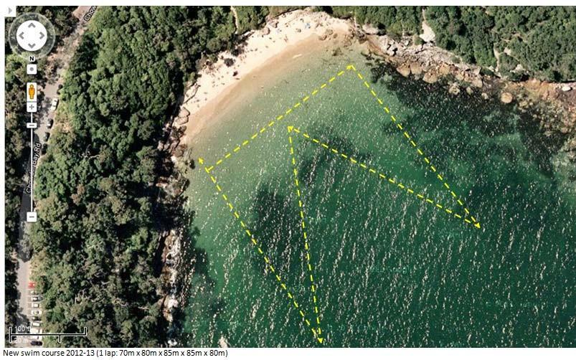
Start/finish

During the race, there will be a race official on a board providing water safety. If you require assistance during the swim leg, raise your hand and a race official will be with you as soon as possible.

Wetsuits

Wetsuits are optional for water temperatures up to 22 degrees Celsius. Above this temperature, wetsuits are not permitted. Wetsuits must meet Triathlon Australia acceptable standards.

The Race Director will decide whether wetsuits are permissible by 6:20am on race and this will be posted on a board in registration.

TRANSITION 1 – SWIM TO BIKE

From the swim finish, proceed from Obelisk Beach up the stairway and head in a northerly direction along Chowder Bay Road, keeping to the far right-hand side of the road.

Please exercise extreme caution when moving up the stairway (steep and uneven surface) and along the road (shared with bike traffic).

Enter the transition area via the RUN ENTRY (Northern Entry Point).

You must ensure any discarded swim gear is placed out of the way of other competitors and that your helmet is securely fastened on your head before un-racking your bike.

Exit the transition area via the CYCLE EXIT (Southern Exit Point)

Upon leaving transition, proceed ON FOOT to the MOUNT line (speed bump). You must NOT mount your bike until crossing the MOUNT line.

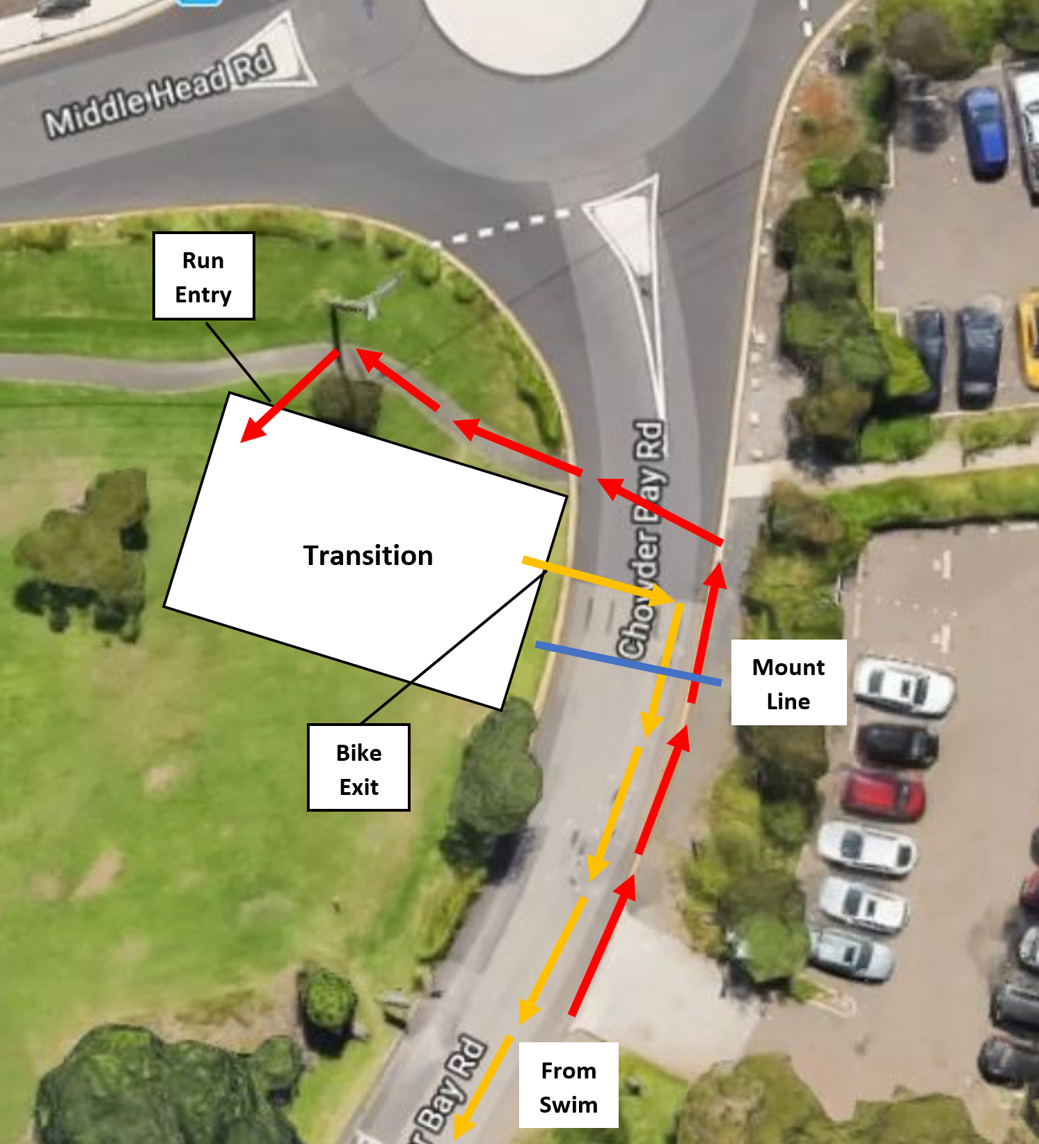

BIKE LEG – 15KM (5 LAPS)

Last lap cut-off at 7.30am - bike course closes at 7.45am. All competitors must be off the bike course (Chowder Bay Road) by 7:45am. Race Officials will direct competitors off the course after this time and the competitor will be recorded as a DNF.

From the MOUNT LINE, proceed south 1.5km along Chowder Bay Road until reaching a permanent roundabout.

At the roundabout, complete a U turn and head north back along Chowder Bay Road for 1.5km until reaching witches hats, marking the completion of one lap.

Complete a U turn around the witch’s hats to commence the next lap.

Chowder Bay Road is 1.5km in length (3km loop). Each competitor is required to complete 5 laps. It is the competitor’s responsibility to keep count of the number of laps they have completed.

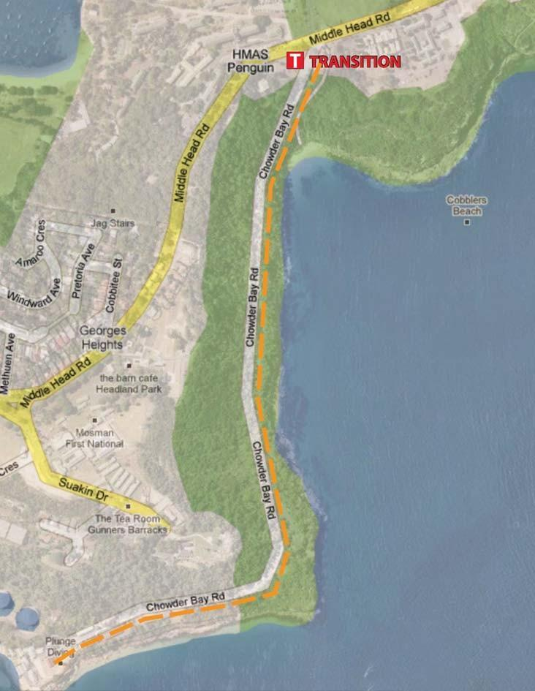

Things to be aware of on the bike course:

- No blocking:
  - Keep left unless overtaking
  - No more than 2 cyclists may ride abreast at any one time and only when one cyclist is overtaking another
- Do not cross the middle of the road at any time as this could give rise to collisions with on-coming competitors and will result in disqualification by the Race Director
- No drafting. Maintain a distance of at least 10m from the bike in front unless overtaking. You have 20 seconds to complete your overtaking.
- Overtake on the right only. Over-taking on the left (“undertaking”) will result in disqualification by the Race Director
- There are 6 speed humps along the course and the course can be affected by potholes, sea breezes, bush turkeys and debris from overhanging trees. Competitors should remain vigilant at all times and be careful when negotiating over or around any obstacles
- The roundabout is off camber whilst the near turnaround point is very tight. Slow down adequately to ensure safe negotiation of both turnaround points.
- Despite the road closure, BTC cannot guarantee Chowder Bay Road will be free from traffic. Please remain vigilant and follow NSW road rules at all times

Infringements

Race officials will not be policing the bike course. Race participants are expected to behave in a sporting manner, do what’s right and abide by the rules and guidance as set out in this race manual.

Sag Wagon

There will be no sag wagon for this event. If you retire from the race (and are not injured) walk your bike back to transition. Be aware that other competitors have right of way. You must notify race officials of your withdrawal from the race.

TRANSITION 2 – BIKE TO RUN

Once you have completed 5 laps of the course, dismount your bike before the DISMOUNT line (speed bump).

Enter the transition area via the CYCLE ENTRY (Southern Entry Point).

Your helmet must remain securely fastened to your head until you have re-racked your bike. Ensure any discarded cycling gear is placed out of the way of other competitors before starting the run leg.

Exit the transition area via the RUN EXIT (Northern Exit Point). Please exercise caution when crossing any roads during the run leg.

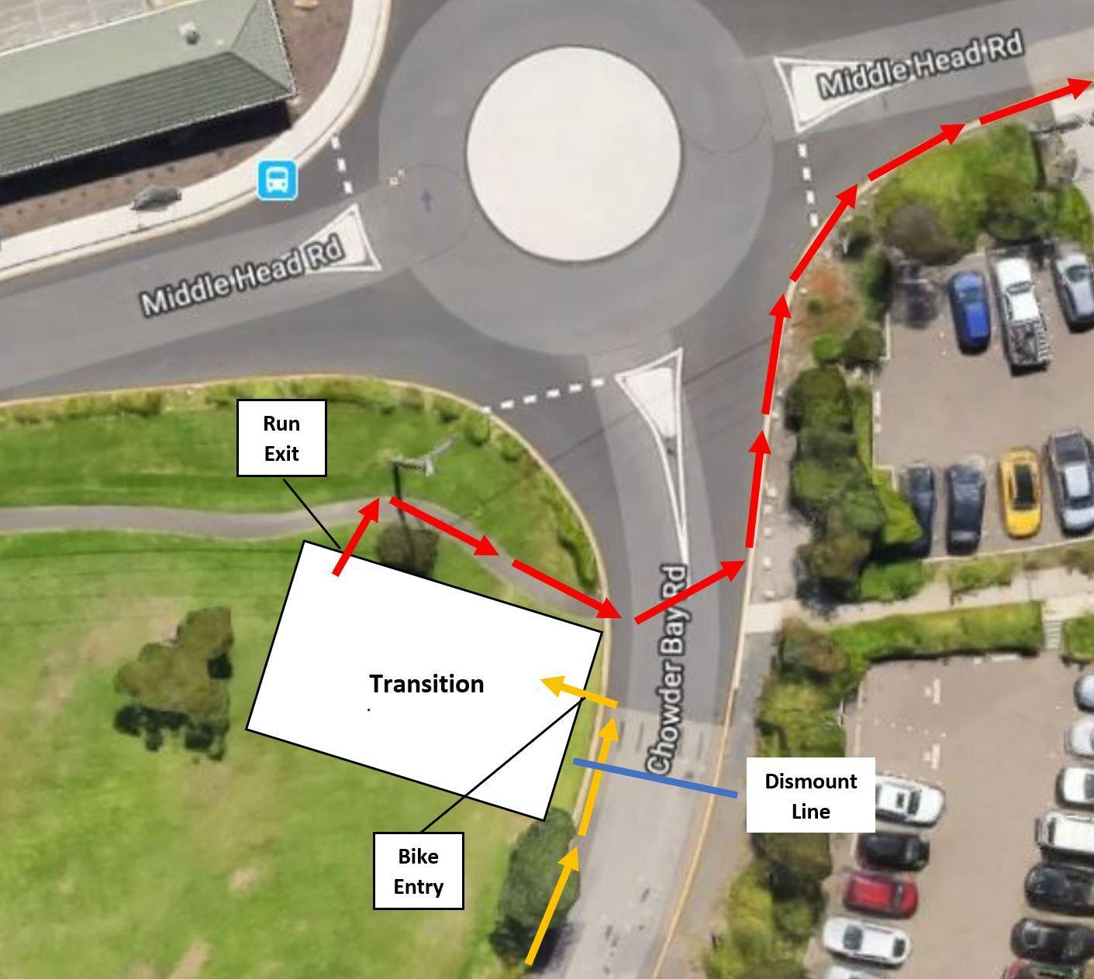

RUN LEG – 4.0KM (2 LAPS)

The run leg closes at 8.30am. All competitors must complete the run course by 8:30am. Race Officials will direct competitors off the course after this time and the competitor will be recorded as a DNF.

From transition, cross the entrance to Chowder Bay Road and head east along Middle Head Road toward Middle Head Reserve. Middle Head Road is not closed to traffic - please keep to the right-hand side of the road.

Upon reaching a boom gate, take the right-hand fork and follow the cones and signs marking the rest of the run course.

Race officials will direct you and provide assistance where necessary. Please follow their instructions at all times.

Exercise caution at all times on the run course:

- The trails are uneven and can be muddy. Rabbit holes have also been found in grassy areas of the course, including the oval;
- Surfaced roads can also be in varying states of repair and will be open to other users

There are no distance markers on the run course. Upon passing the finish chute on Middle Head Oval, competitors will have completed one lap (2.25km). Each competitor is required to complete 2 laps.

FINISH

Upon completion of your 2nd run lap, enter the finish chute and run past the finish flags, shouting out your race number as you do so.

After you finish, please return to transition and once all competitors have started the run leg, collect your belongings and head home.

RESULTS & PRIZE GIVING

Results will be available on the BTC website.

There will be no public presentation ceremony (due to Covid-19 precautions).

The top three male and female finishers will be recognised and awarded medals, which will be posted out to winners. A lucky prize draw based on race numbers will take place on line and be posted on the BTC website.

Race results should be published on the BTC Facebook page within 48 hours of the race, and on the BTC website during the week following the race.

COLLECTION OF PERSONAL BELONGINGS

Bikes and other transition gear can be picked up once the last runner has left the transition area (approximately 8.00am). Please take only your own equipment and avoid disturbing other competitor’s belongings.

LOST PROPERTY

Ensure that all your race equipment and personal belongings carry some form of identification in case it is misplaced and handed in to race officials. The race organisers accept no responsibility for lost or stolen property.

CONTINGENCY PLAN

In the event of extreme conditions* and at the discretion of the Race Committee, the following contingency plans may come into effect:

- Plan A: Official race start delayed to allow time for the weather/situation to pass.
- Plan B: Race proceeds as a duathlon (if safe to do so), with the first leg as per 1 lap of the run course in lieu of a swim.
- Plan C: Race proceeds as a run only (no swim or bike leg).
- Plan D: Race cancelled (Note: If the race is cancelled prior to the race start, the Race Committee will attempt to reschedule to another date if permissible to do so).

In the event of a medical emergency, the race may be cancelled at any time prior to or during the race.

*Extreme Conditions

Extreme conditions include and not limited to: Poor water quality, unsafe conditions causing potential danger to competitors and race officials.

Plan A - Delayed Race Start

The official race start cannot be delayed any later than 6.40am due to road closure requirements. In the event of a delayed start, the existing cut-off times for each race leg remain unchanged.

*** Decision to be made prior to race start by Race Director ***
If Plans B, C or D are selected, NPWS, SHFT, Mosman Council, NSW Police & Triathlon NSW to be notified

Plan B – Duathlon

Race details (no change to run & bike course maps above):
Run Leg 1: 1 lap of run course (2.25km)
T1: Run to Bike
Cycle: 5 laps of bike course (15km)
T2: Bike to Run
Run Leg 2: 2 laps of run course (4.5km)

Plan C - Run Only

Race details (note: Run course change below):

Run Option 1 (1 lap, 5km):

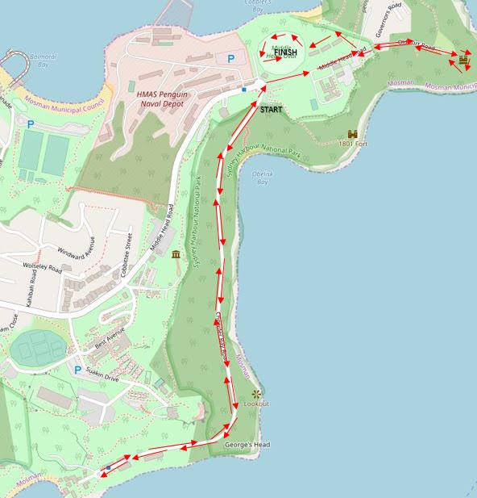

Run Option 2 - if oval is unavailable (2 laps, 6km total):

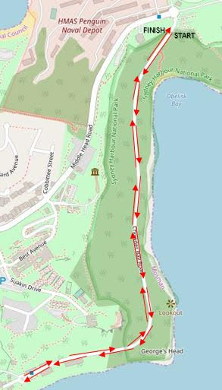

Plan D - Race Cancellation

Decisions regarding the cancellation of part of or the entire race can be made by the Race Committee at any time prior to or during the race.

AND FINALLY

Please enjoy yourselves and have a safe race. If you have any questions, please do not hesitate to approach any of the race officials before or after the race.

Good luck!

The BTC Race Committee

